
national Public School
HSR Bengaluru

Worksheet No.: NPSHSR/2024-25/CT/GR12/BUSINESS STUDIES/02 Date: 26/03/2024
TOPIC: Principles of Management

1 | For the last three years, Elpis Technology Solutions p(Ltd.) is not functioning smoothly and systematically. The relations between management and employees are becoming bitter day by day. After a complete analysis, it was observed that employees are not working effectively and efficiently and management is not fulfìlling its commitment of increments and promotions,  i. Which management principle is being ignored in the given case?  ii. Can the problem be solved if only management becomes serious in fulfilling its  promises? What should be the appropriate course of action to achieve smooth and  systematic functioning of Mahagun Industries?
2 | What are the adverse effects of the violation of the following principles? Give one  adverse effect for each.  a. Division of work  b. Unity of Command  c. Remuneration  d. Order  e. Stability of tenure
3 | The Production Manager of Bharat Ltd. instructs a salesman to go slow in selling the product, whereas the Marketing Manager is insisting on fast selling to achieve the target. Which principle of management is being violated in this case? State any one of the consequences of violation of this principle.
4 | Match the principle of management in Column I with their respective explanation in Column II:  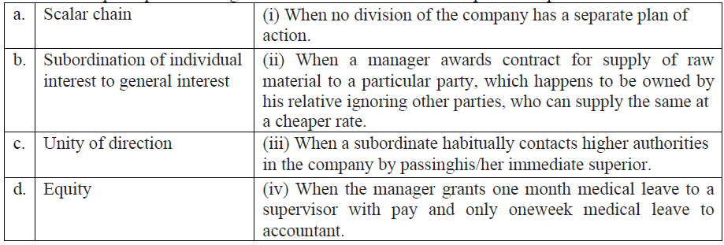  (a) (i), (ii), (iii), (iv) (b) (ii), (i), (iii), (iv)  (c) (iii),(ii),(i),)iv) (d) (iii),(i),(ii),(iv)
5 | Match the technique of scientific management in Column I with their respective explanation in Column II:  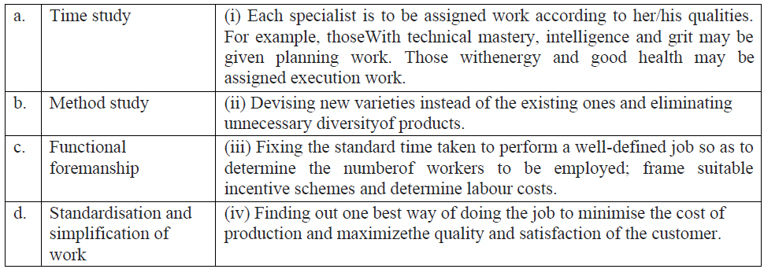  (a) (iii), (ii),(i), (iv) (b) (ii), (i), (iii), (iv)  (c) (iii), (iv), (i), (ii) (d)(i), (iii), (ii), (iv)
6 | Rajat Joined as a CEO of Bharat Ltd. a firm manufacturing computer hardware. On the first day he addressed the employees. He said that he believed that a good company should have an employee suggestion system and he wished to minimize employee turnover to maintain organisational efficiency. He informed all employees that he would ensure that all agreements were clear, fair and there was judicious application of penalties. However, he said that he believed that lazy personnel should be dealt with sternly to send the message that everyone was equal in the eyes of management. Also that he would want to promote a team spirit of unity and harmony among employees, which would give rise to a spirit of mutual trust and belongingness among team members and eventually minimize need for using penalties. He told all present that the interests of the organization should take priority over the interests of any one individual employee.  1. Identify the principal of management in the following line. “ He said that he believed that a good  company should have an employee suggestion system”  (a) Unity of command (c) discipline  (b) Unity of direction (d) initiative  2. Identify the principal of management in following line. “He wished to minimize employee  turnover to maintain organizational efficiency.”  (a) Stability of personnel (c) Centralization and Decentralization  (b) Discipline (d) Remuneration of employees  3. Identify the principal of management in the following lines. “He informed all employees that he would ensure that all agreements were clear, fair and there was judicious application of penalties.”  (a) Initiative (c) Discipline  (b) Equity (d) Esprit de corps.  4. Identify the principal of management in the following lines “Which would give rise to a spirit of mutual trust and belongingness among team members.  (a) Discipline (c) Initiative  (b) Unity of command (d) Esprit de corps.
7 | Radhika opens a jewellery showroom in Jaipur after completing a course in jewellery designing. She has employed eleven persons in her showroom. For greater productivity, she divides the work into small tasks and each employee is trained to perform his/ her specialised job. The sales persons are allowed to close a deal with a buyer by giving a maximum of 10% discount, whereas the decision to give any further discounts rests with Radhika as the final authority. In the earlier days of starting of the business, five of her employees were asked the put in extra hours of work. In return she had promised to give them a special incentive within a year. Therefore, after six months when the business was doing well, she awarded a cash bonus to each of these employees to honour her commitment. However, when it comes to settling the conflicts among her employees, she tends to be more biased towards her female employees.  1. Identify the principal of management in “She divided the work into small tasks and each employee is trained to perform his/her specialised job”  (a) Unity of command (c) Division of work  (b) Unity of direction (d) Discipline  2. Identify the principal “The sales persons are allowed to close a deal with a buyer by giving a maximum of 10% discount, whereas the decision to give any further discount rests with Radhika as the final authority”  (a) Division of work (b) Discipline  (c) Initiative (d) Centralisation and decentralisation  3. Identify the principal of management in the following lines. “Therefore after six months when the business was doing well, she awarded a cash bonus to each of these employees to honour her commitment.  (a) Discipline (b) Initiative  (c) Scalar chain (d) Remuneration  4. Which principle is violated in the following lines. “However when it comes to setting the conflicts among her employees, She tends to be more biased towards her female employees.”  (a) Discipline (b) Equity  (c) Division of work (d) Justice
8 | As students of a management course Karan and Kunal were asked to prepare a project report on applicability of principles of management in real business situations. In order to conduct the survey Kunal had selected an outlet of a popular chain of fast food restaurant whereas Karan visited a nearby department store. When Kunal presented his report to class, Karan realised that their observations were matching on various grounds. In both the business units, work is divided into  small tasks and each is performed by a trained employee. A set of rules are predetermined and communicated to employees for compliance and these is a fixed place for every thing and all employees have been allotted individual space. Moreover, the manager encourage a spirit of mutual trust and belongingness among the employees so that need for imposing penalties is reduced.  1. Identify the principal of management in the following lines “work is divided into small tasks and each is performed by a trained employee.”  (a) Unity of direction (b) Unity of command  (c) Division of work (d) Initiative  2. Identify the principal of management in following lines “A set of rules are predetermined and communicated to the employees for compliance.”  (a) Discipline (b) Scalar chain  (c) Unity of command (d) Unity of direction  3. Identify the principles of management in the following lines: “There is a fixed place for everything and all employees have been allotted individual space”  (a) Unity of direction (b) Order  (d) Scalar chain (d) Equity  4. Identify the principle of management in the following lines: “Managers encourage a spirit of mutual trust and belongingness among the employees”  (a) Unity of command (b) order  (c) Equity (d) Esprit de corps

ANSWERS
1 | i. The principle of 'Discipline' is being violated.  ii. No, the problem cannot be solved through management efforts only. For smooth  and systematic functioning of Elpis Technology Solutions p(Ltd.), both employees  and management should be disciplined. Employees must be disciplined to work  effectively and efficiently and management should meet their commitment of  increments and promotions.
2 | Following are the consequences or adverse effects of each of these principles:  a. Division of work: The violation of this principle leads to the dearth of  specialization among the employees.  b. Unity of Command: The violation of this principle leads to confusion in the mind  of the subordinate in following the orders.  c. Remuneration: The violation of this principle leads to a situation of unrest among  the employees and makes them demotivated.  d. Order: Improper placement of men and material may lead to wastage of  resources.  e. Stability of tenure: Instability and insecurity among employees and they would  tend to leave the organization.
3 | The principle of management which is being violated in this case is Unity of  Command. Consequence will be that salesman will be confused regarding whose  instructions should he follow. Therefore, it may be difficult to carry out the order of  two persons when they are contradictory.
4 | (c) (iii),(ii),(i),)iv)
5 | (c) (iii), (iv), (i), (ii)
6 | D,A,C,D
7 | C,D,A,B
8 | C,B,B,D

